**Build and Release pipeline for deploying application using AKS**

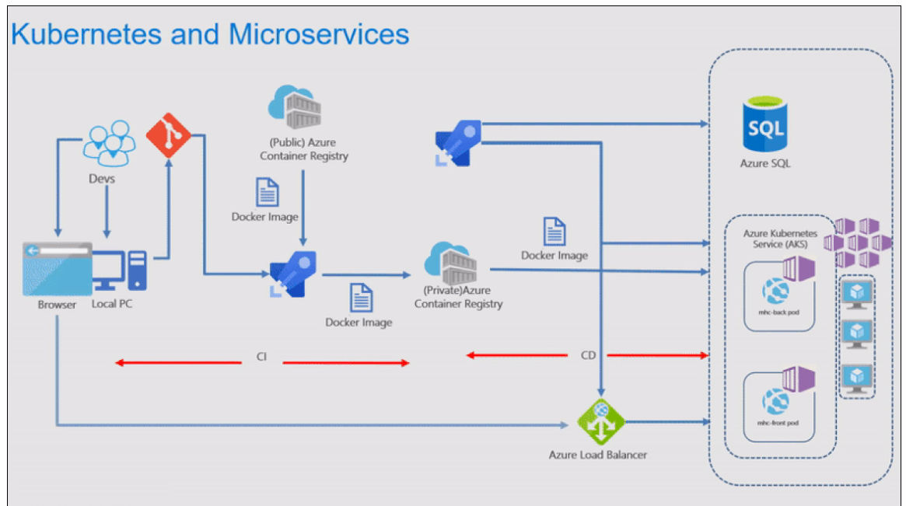

**Build Pipeline**

[**https://azuredevopslabs.com/labs/vstsextend/kubernetes/**](https://azuredevopslabs.com/labs/vstsextend/kubernetes/)

**Note:** Create AKS project from demo generator and do not forget to install “replace token” from market place.

number=$RANDOM

RGNAME=aksdemoRG$number

LOCATION='eastus'

AKSNAME='akscluster'$number

SQLNAME='sqlserver'$number

ACRNAME='acr'$number

VERSION=$(az aks get-versions --location $LOCATION --query 'orchestrators[-1].orchestratorVersion' --output tsv); echo $VERSION

az group create --name $RGNAME --location $LOCATION

az aks create --location $LOCATION --resource-group $RGNAME --name $AKSNAME --enable-addons monitoring --kubernetes-version $VERSION --generate-ssh-keys

az sql server create --location $LOCATION --resource-group $RGNAME --name $SQLNAME --admin-user sqladmin --admin-password P2ssw0rd1234

az sql server firewall-rule create --resource-group $RGNAME --server $SQLNAME --name allowAzure --start-ip-address 0.0.0.0 --end-ip-address 0.0.0.0

az sql db create --resource-group $RGNAME --server $SQLNAME --name mhcdb --service-objective S0 --no-wait

az acr create --location $LOCATION --resource-group $RGNAME --name $ACRNAME --sku Standard

# Retrieve the id of the service principal configured for AKS

CLIENT_ID=$(az aks show --resource-group $RGNAME --name $AKSNAME --query "identityProfile.kubeletidentity.clientId" --output tsv)

# Retrieve the ACR registry resource id

ACR_ID=$(az acr show --name $ACRNAME --resource-group $RGNAME --query "id" --output tsv)

# Create role assignment

az role assignment create --assignee $CLIENT_ID --role acrpull --scope $ACR_ID

echo $(az sql server list --resource-group $RGNAME --query '[].name' --output tsv)'.database.windows.net' # sqlserver24530.database.windows.net

az acr show --name $ACRNAME --resource-group $RGNAME --query "loginServer" --output tsv # acr24530.azurecr.io

**Release Pipeline**

**DB deployment - DB Agent details**

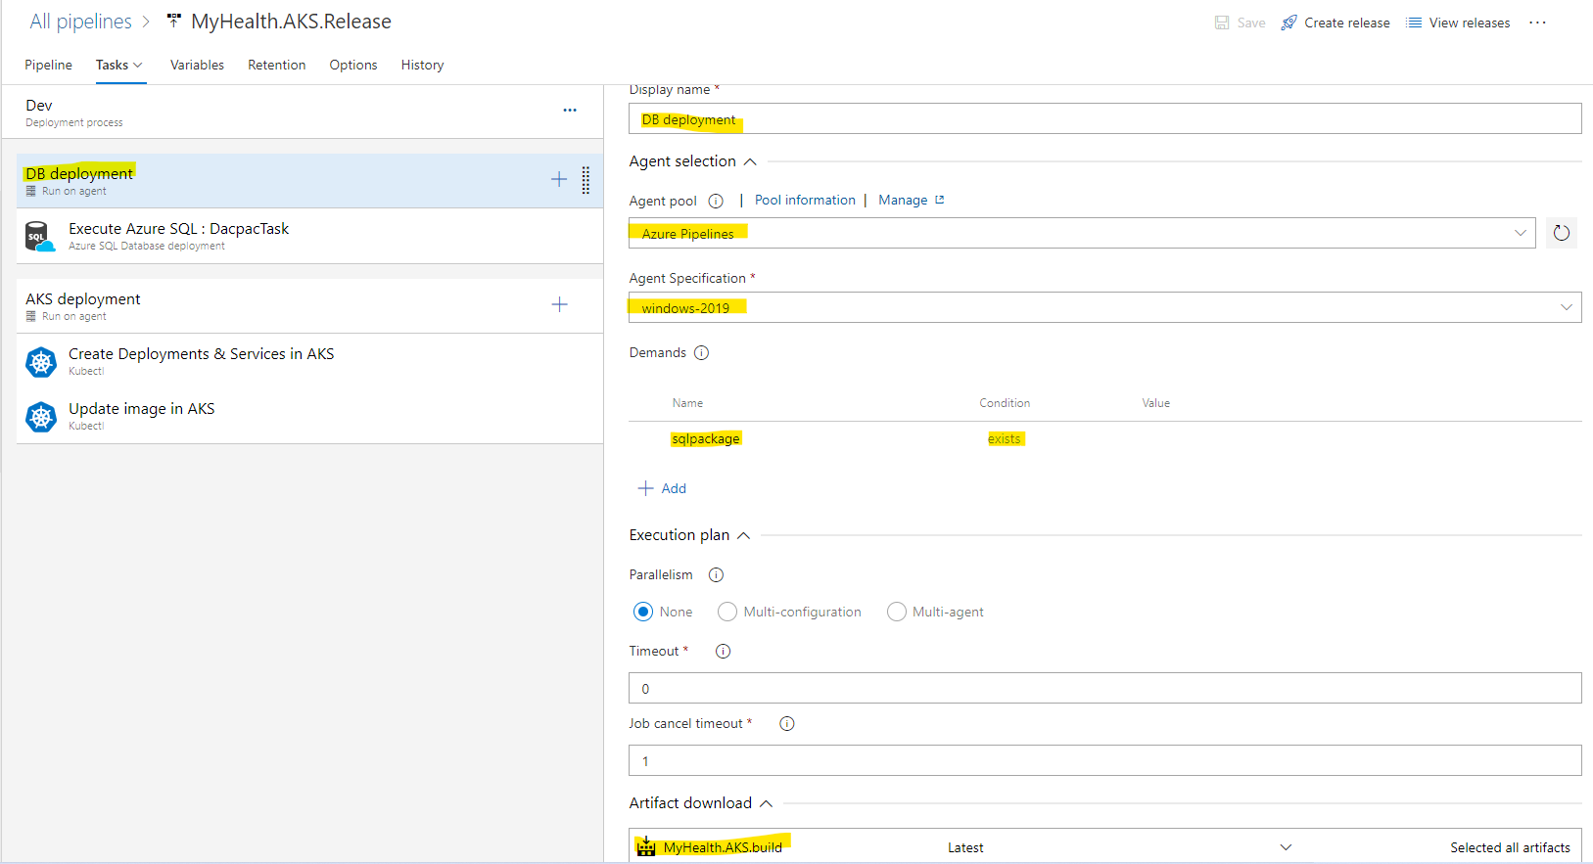

**Task-1: Execute Azure SQL**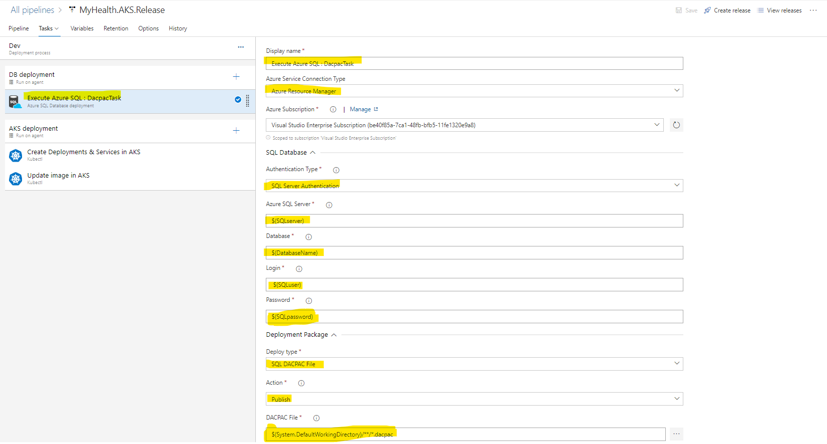

**Variables**

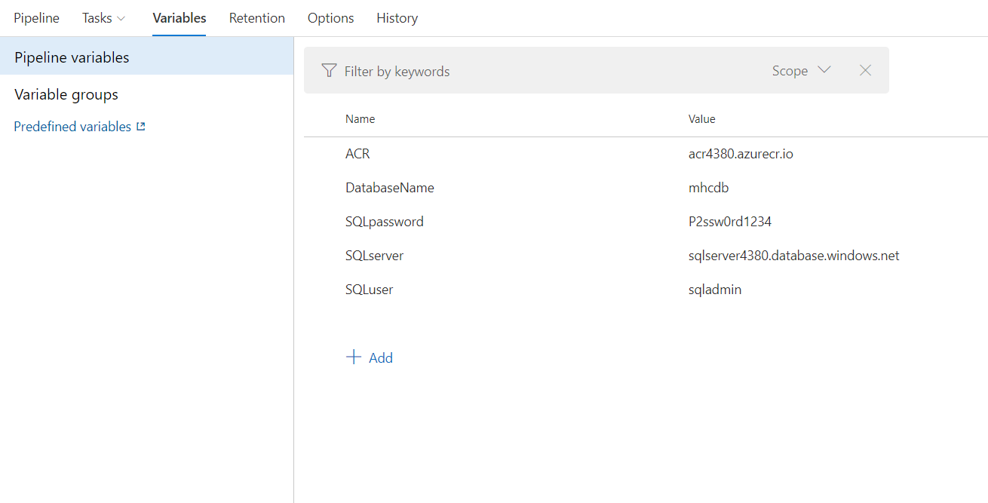

**AKS deployment - AKS Agent details**

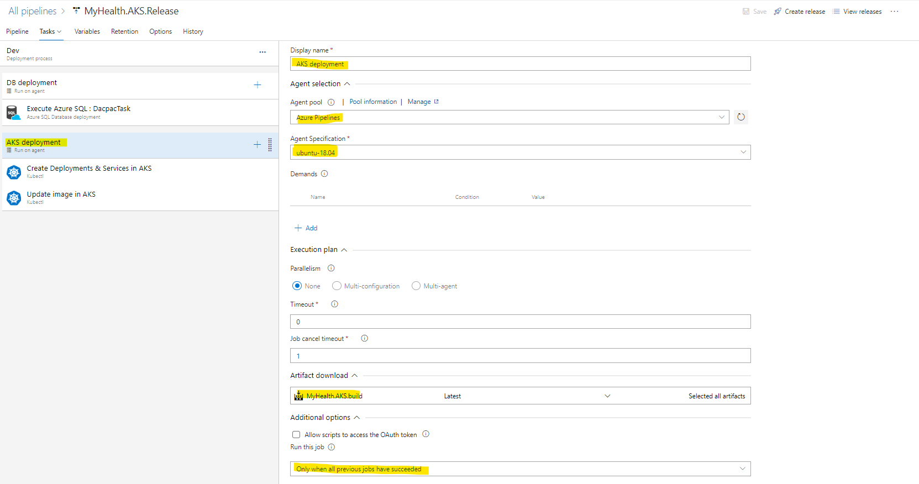

**Task-1:**

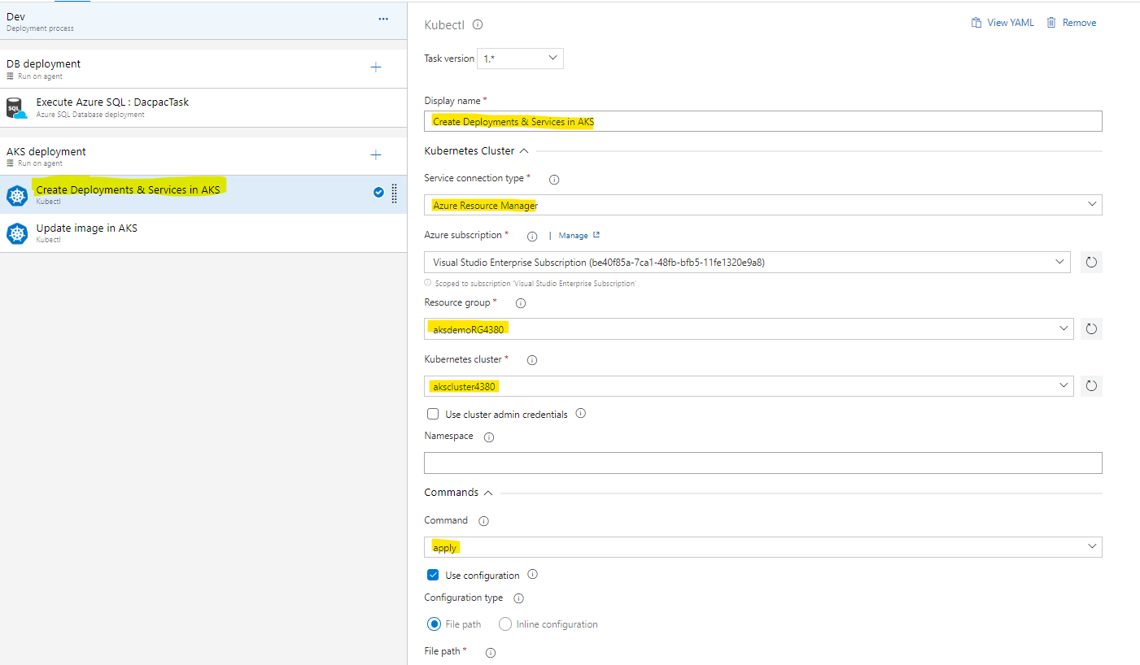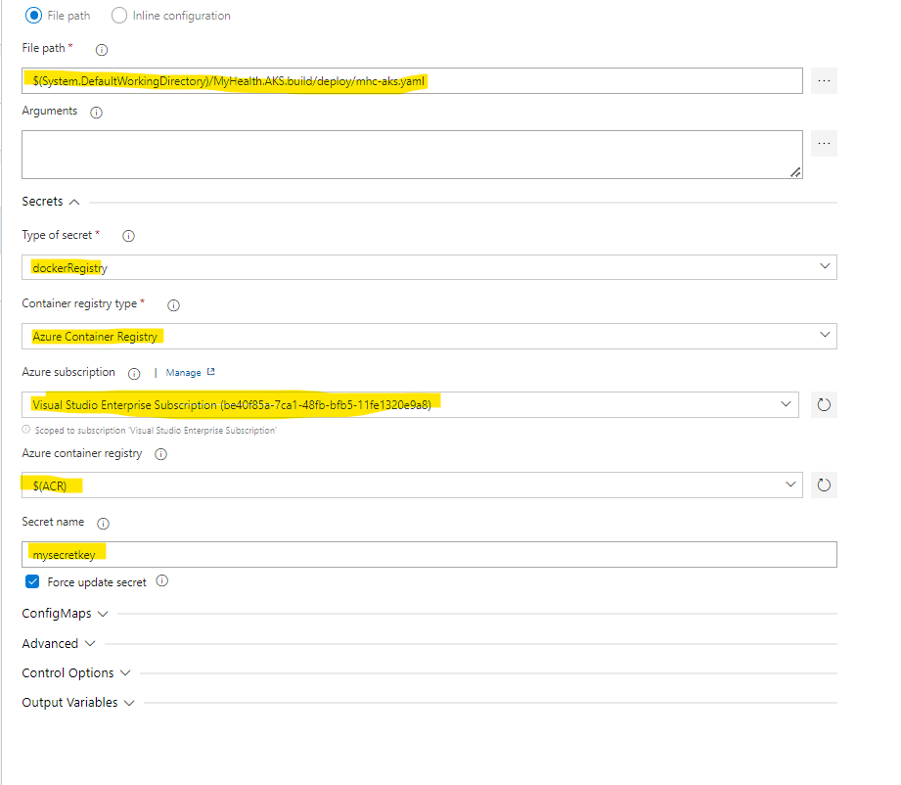

Task-2

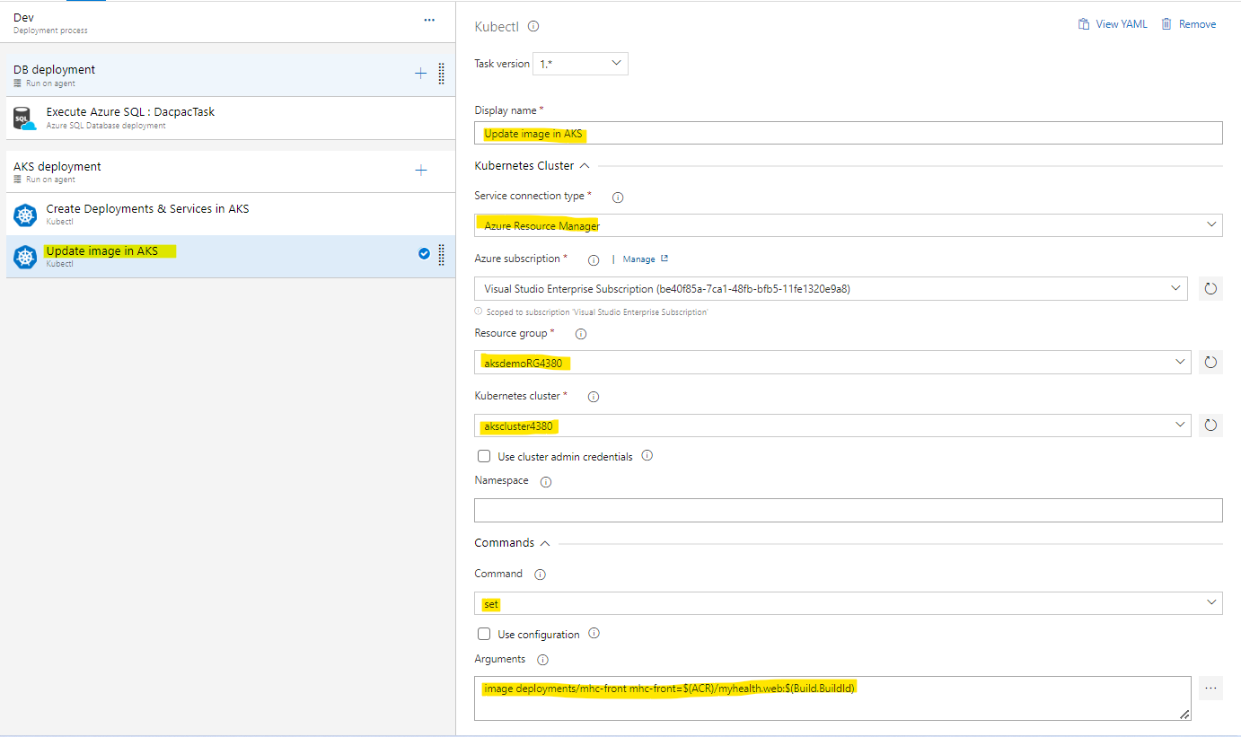

Command Arguments : image deployments/mhc-front mhc-front=$(ACR)/myhealth.web:$(Build.BuildId)

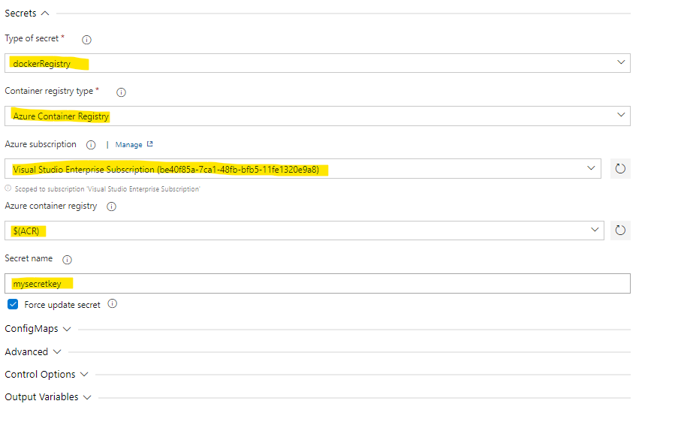

**Post deployment**

az aks get-credentials --resource-group $RGNAME --name $AKSNAME

kubectl get pods

kubectl get service mhc-front --watch

kubectl scale deployment --replicas=2 mhc-front